

**Faculty of Green Energy and Technology**

**BACHELOR OF TECHNOLOGY (HONOURS) IN   
ELECTRONIC SYSTEMS**

**Work Based Learning - Machine Vision I**

**Assignment 3 Frequency Domain Filter FFT**

1. **Anand Low Hong Ren 1801371**

**Introduction**

In this assignment, the objective is to apply knowledge of frequency domain to filter artifacts out of images. For the first part, I will remove the dot pattern from the moon landing photo. For the second part, I will remove wavy or banding artifacts present in various images captured by inspection machines in Vitrox.

Frequency domain filters process not on the image itself, but on the Fourier transform of the image. This means that processing occurs in the Fourier domain or most commonly called frequency domain. The overall idea is that an image is Fourier transformed, then the filter function also undergoes Fourir transformation, then the two is multiplied together, and lastly inverse Fourier transformed back into the spatial domain image.The transform of the image has two components which are magnitude and phase. The magnitude consists of the frequency content of the image, while the phase is used to restore the image back to the spatial domain which results in our output image. Frequency filtering ignores the presence of any object or regions in the image and processes the whole image, whereas spatial filtering usually requires image segmentation first to find the ROI, which is likely to fail if the segmentation fails. Mask boundaries are also pretty tricky to fit the object precisely. It is a good option if you need to do noise reduction, refocusing, image smoothing, energy extraction, compression and others. Frequency filtering is better than spatial filtering depending on the scenario. All frequency filters can likewise be executed in the spatial domain and, if there exists a basic kernel for the required filter effect, it is computationally more affordable to use spatial filtering (Alrammah, n.d. ). Frequency filtering is more suitable in the case where no direct kernel can be found in the spatial domain, and may likewise be more proficient (Fisher et al, 2003).

The main principle behind frequency domain techniques in image processing is based on 2-D discrete Fourier Transform. The convolution theorem states that convolution in the spatial domain is equivalent to multiplication in frequency domain. If the function of image is ***f(x,y)*** and a filter is ***h(x,y)*** , In spatial domain the filtered output can be written as ***f(x,y)∗h(x,y*)** where * represents the convolution operator. But in frequency domain the filtered output is ***F(u,v)×H(u,v)*** where ***F(u,v)*** where ***H(u,v)*** represent Fourier transformation of ***f(x,y)***  and ***h(x,y)*** respectively shown in Equation 1.

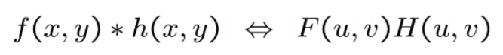

**Equation 1: Convolution theorem**

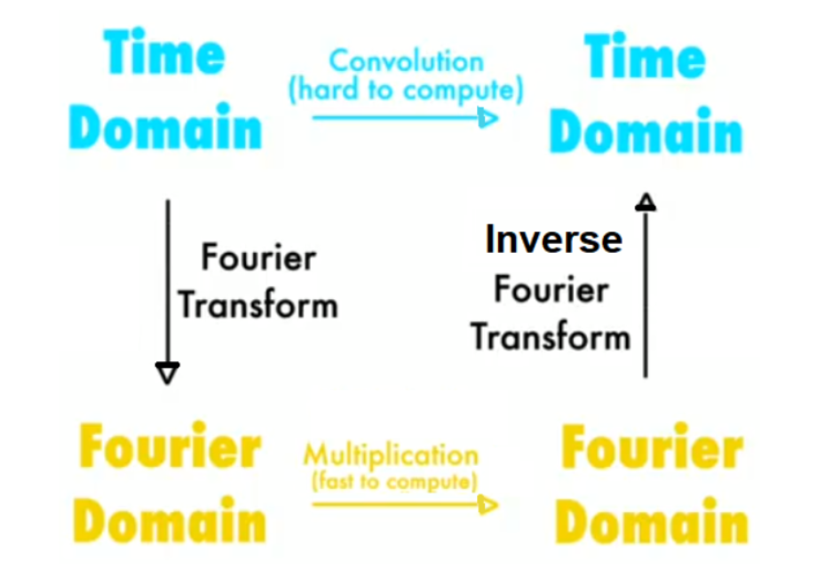

**Figure 1: Application of fourier transforms in image processing**

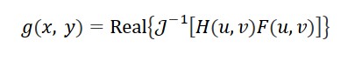

**Equation 2: basic filtering equation**

Where ${ 𝒥}^{-1}$ is the inverse discrete Fourier transform, while *F(u,v)* is the discrete Fourier transform of the input image, *f(x, y), H(u,v)* is a filter transfer function, and *g(x, y)* is the output image.

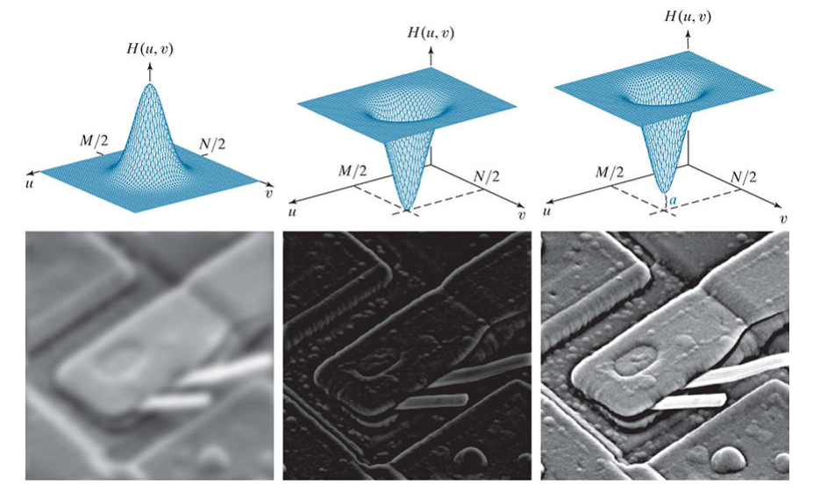

**Figure 2: Image after apply frequency domain filter**

1. **A lowpass filter**
2. **A highpass filter**
3. **An offset highpass filter**

In general, for the sinusoidal signal, if the amplitude varies in an exceedingly short time ( high rate of change), you can say it is a high frequency signal. If it varies slowly, ( low rate of change) it is a low frequency signal. a lowpass filter smoothes or blurs by attenuating the high-frequency part of the sinusoidal wave. The application for image blurring employing a lowpass filter are machine recognition systems or OCR to bridge little gaps in alphabets in the text. Next, it is also used in publishing where it is often accustomed to remove blemishes/lines and obtain a softer and smoother result in applications such as photoshop. A highpass filter is used for image sharpening to amplify edges by removing low-frequency content.

**Methodology**

In digital image processing, the frequency spectrum of an image can be calculated in several ways, but the FFT method is the only one that is practical. The original image must be composed of N rows by N columns, where N is a power of two, i.e., 256, 512, 1024, etc. If the dimensions of the original image is not a power of two, zero pixels are added to create the proper size. The array that holds the image will be called the real array. Additionally, another array of the identical size is required, which we will call the imaginary array.

The way for calculating the Fourier transform of an image is as follows. The program takes the one-dimensional FFT ( Fast Fourier Transform) of each of the rows, followed by the one-dimensional FFT of each of the columns. Specifically, start by taking the FFT of the N pixel values in row 0 (first row) of the real array. The real part of the FFT's output is placed back into row 0 of the real array, while the imaginary part of the FFT's output is placed into row 0 (first row) of the imaginary array. This step is repeated for every row. Next, the procedure is repeated on each of the columns. Both arrays have been overwritten with the image's frequency spectrum.

**Results and Observations**

**Part 1**

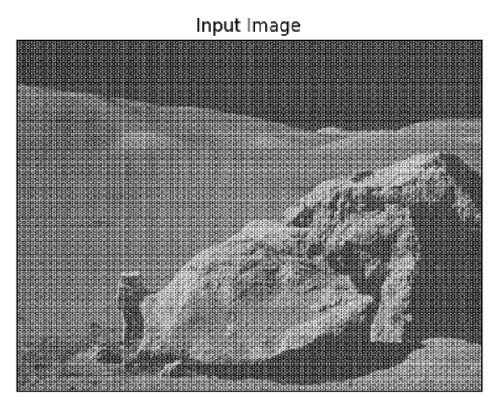

**Figure 3: Original Image of moon landing**

The phase spectrum does not give any good interpretation therefore we will only focus on the magnitude spectrum of the frequency domain.

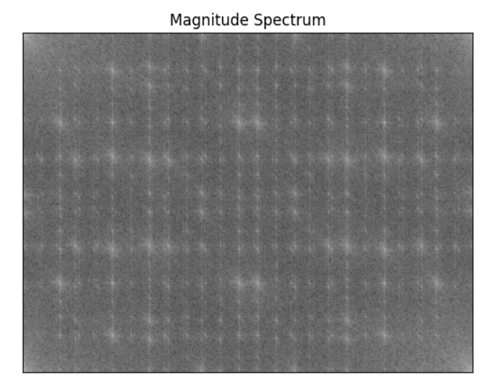

**Figure 4: Magnitude Spectrum**

The speckles of whilte that look like stars are caused by the white and black dots shown in Figure. The bright spots in the four corners indicate the low frequency content of the image.

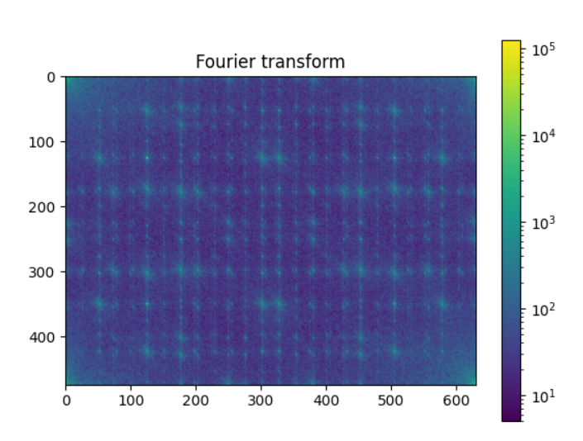

**Figure 5: After add colour mapping to the magnitude spectrum**

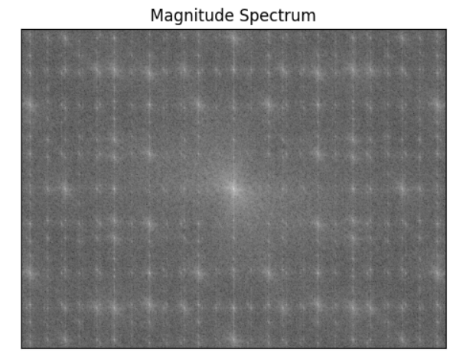

**Figure 6: Magnitude spectrum of the image after fft.shift**

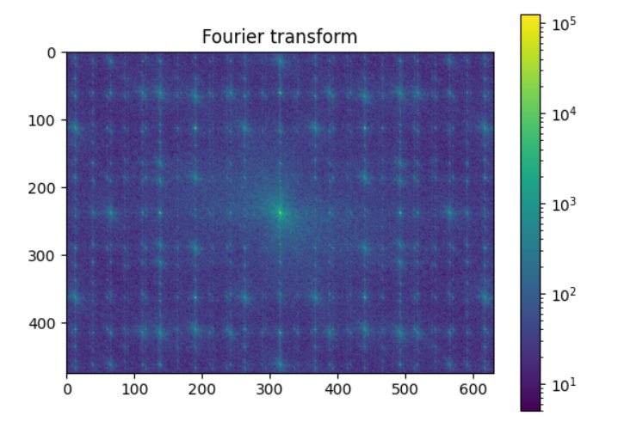

**Figure 7: Magnitude spectrum of the image after shift after apply colour map**

We can use np.fft2.fftshift to move the low frequency content from the 4 corners to the centre.

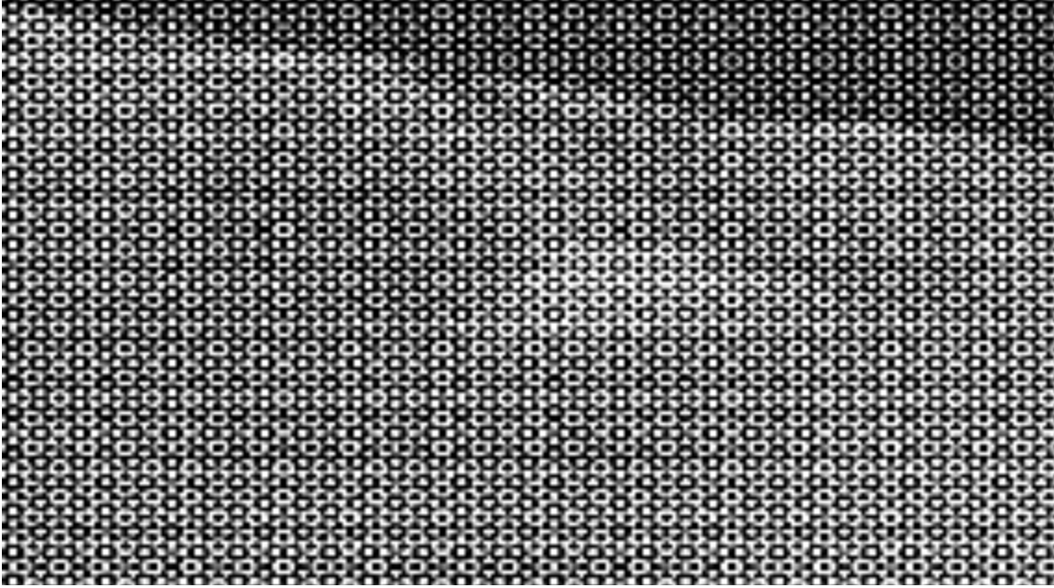

**Figure 8: Black and white dot pattern in the original image**

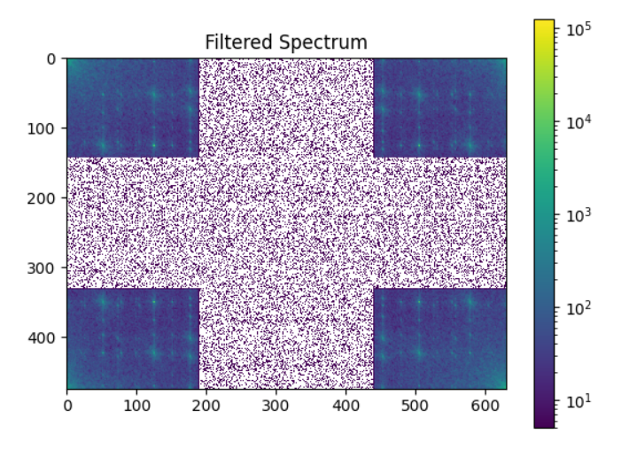

**Figure 9: keep_fraction is set to 0.3**

The cropping method used here is keeping the 4 corners while cropping the rest. This is important as the high frequency contents are usually the important details in the image that needs to be kept. The code for the area cropping is shown below.

|  |
| --- |
| im_fft2[int(row * keep_fraction): int(row * (1 - keep_fraction))] = 0  im_fft2[int(: , column *keep_fraction ):int(column * (1 - keep_fraction))] = 0 |

**Code 1: Area cropped**

To further clarify, the first row crops the rows in the middle depending on the keep fraction. The second line crops the middle columns from top to bottom also depending with the keep fraction.

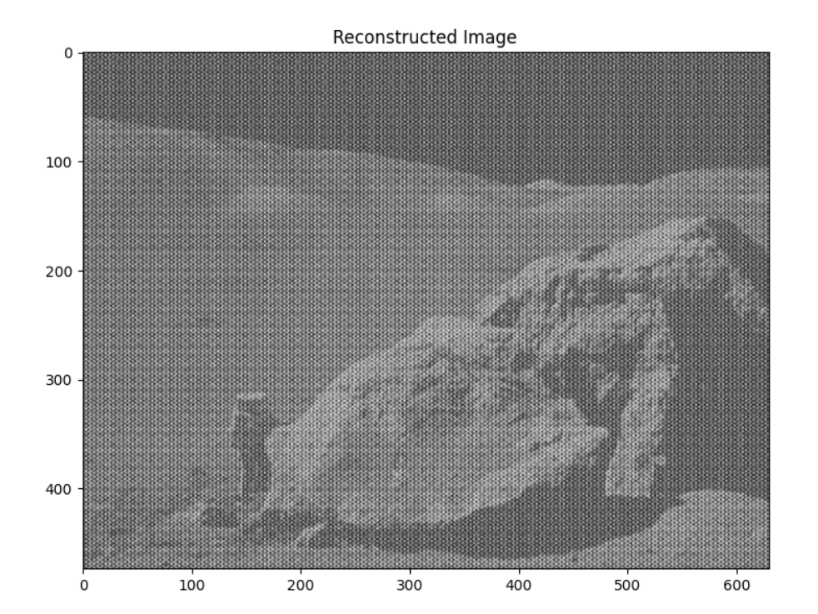

**Figure 10 : Image after keep_fraction = 0.3 filtered magnitude spectrum**

The contrast is decreased compared to the original image, however the dot patterns are still visible but not as stand out as the original image, because there are still cross like patterns in the frequency domain. If we removed that, I believe that the pattern in the original image will disappear.

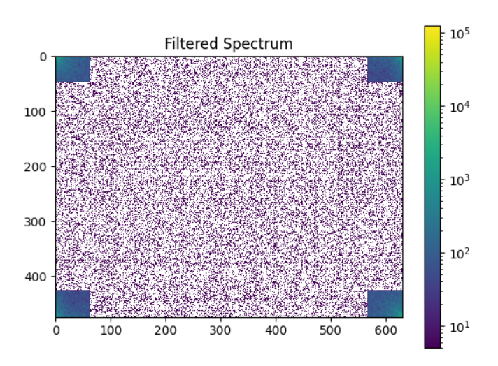

**Figure 11: keep_fraction = 0.1 filtered magnitude spectrum**

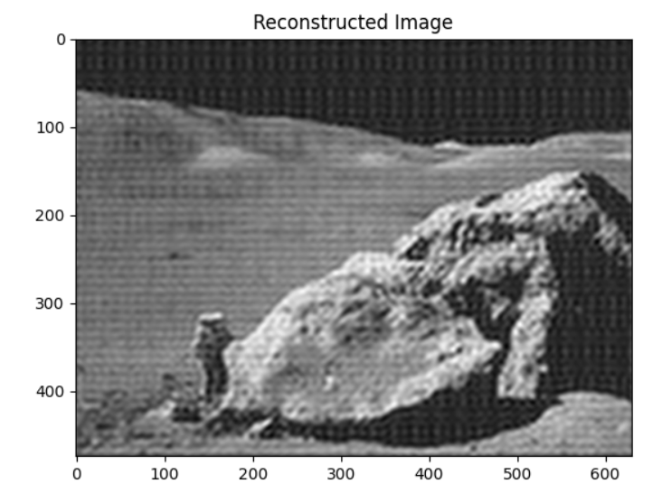

**Figure 12: keep_function is set to 0.1**

As we can see here, after we remove the dot pattern in the frequency spectrum, the dot pattern looks smudged out, which looks cleaner than the original image.

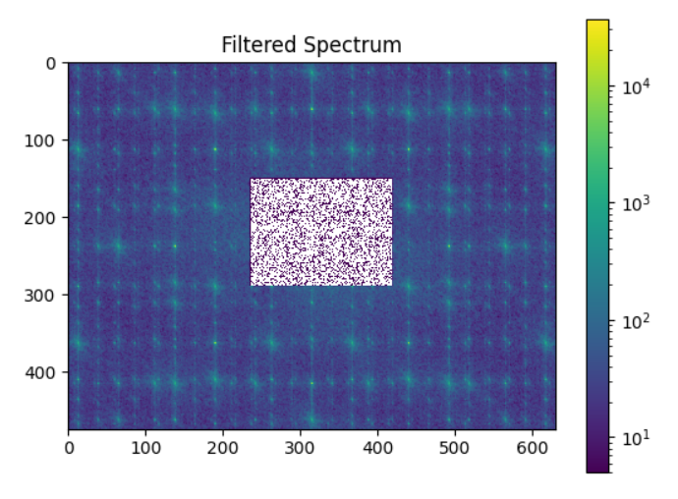

**Figure 13: Cropped the high frequency contents**

I tried using the shifted frequency spectrum and removed the centre high frequency contents, and as we can see in **Figure 14** all the important details such as the astronaut and the hills on the moon are removed, and only the dot pattern remains.

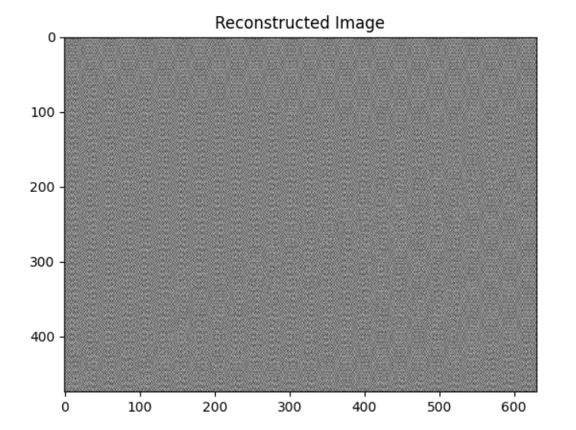

**Figure 14: The resulting image from removing all high frequency contents**

It can be concluded that we have to be careful when removing frequencies from the frequency domain as the important details might be lost if the wrong frequencies are being removed.

**Part 2**

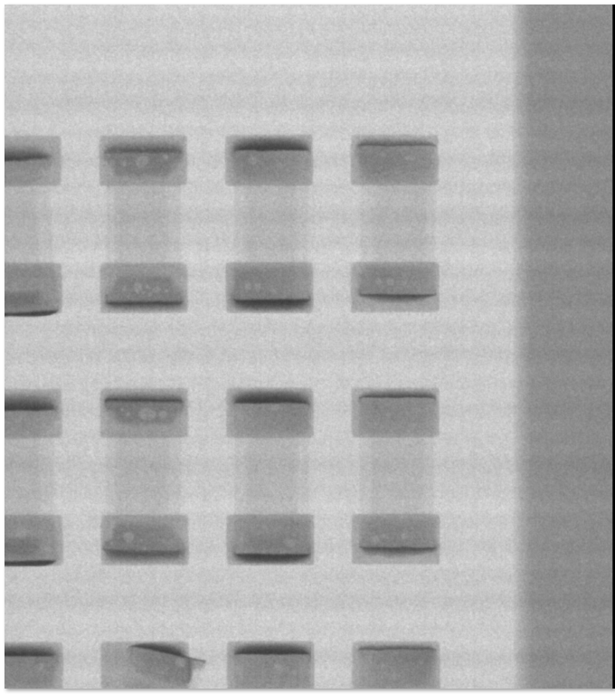

**Figure 15: Original Image with banding effect**

As we can see in Figure 15, there is horizontal banding or “wavy” artifact across the image. This is caused by the setup of the lights and camera setting when the image was taken. The objective is to remove these bandings from the image. A few other images are given and the results will be shown below.

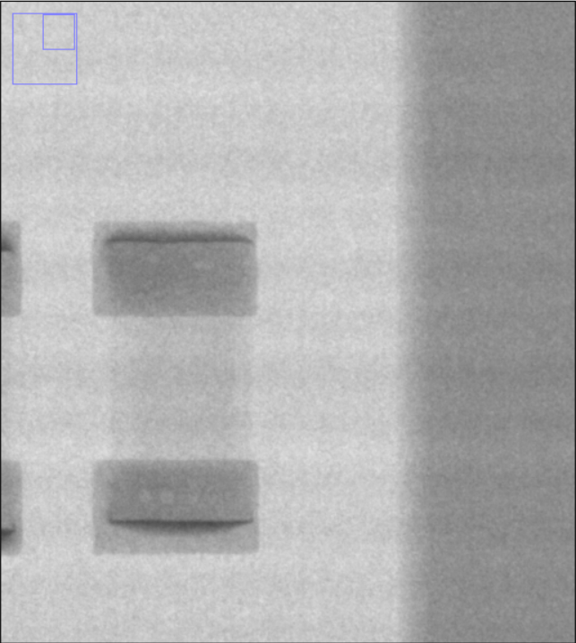

**Figure 16: A close up on the banding effect**

Initially, I tried to use the same algorithm as in Part 1, but the results were not great. The image lost a lot of detail due to the whole image blurring. Therefore, I tried a new approach which is cropping different areas of the frequency spectrum to find the area of frequency spectrum which corresponds to the banding pattern that I want to remove. It is a difficult task as I want to maintain the sharpness of the image, while maintaining the objects in the image so that further image processing can still identify and inspect the objects in the image. After numerous trial and errors in erasing areas of the frequency in the frequency spectrum in the image, I finally found an area of the frequency from (0, 1) to (700, 200) when cropped, removes the banding pattern without sacrificing any detail or sharpness (Figure 18).. However the contrast in some parts of the image are decreased but the object is still exactly untouched and identifiable.



**Figure 17: Cropped magnitude spectrum of the image**

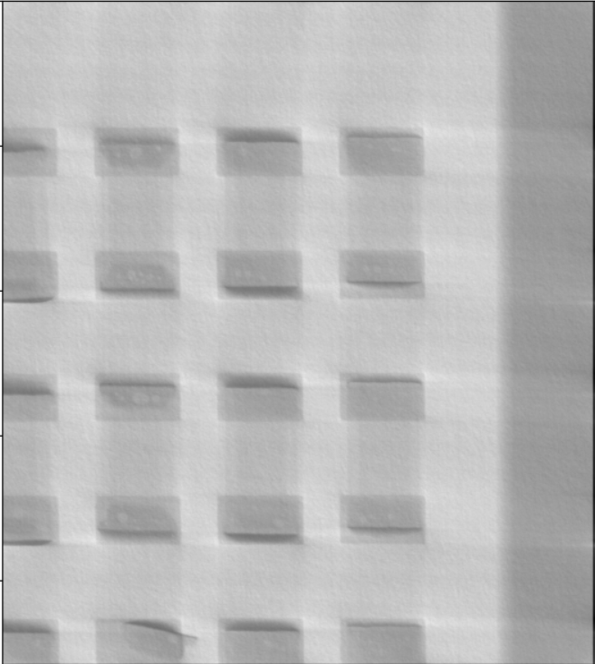

**Figure 18: After removing the banding effect**

Since it works for this image, the code is tested for other flawed images to see whether it will remove the banding effect for other images as well.

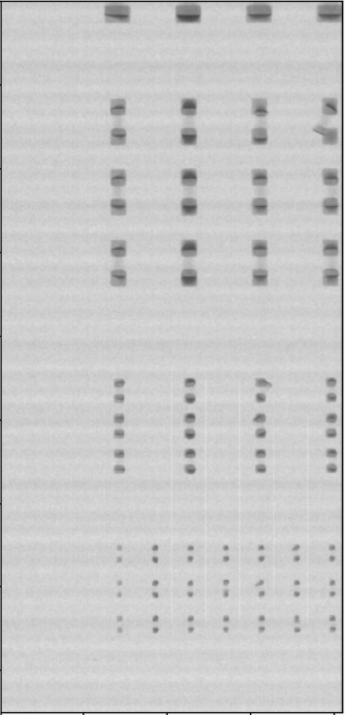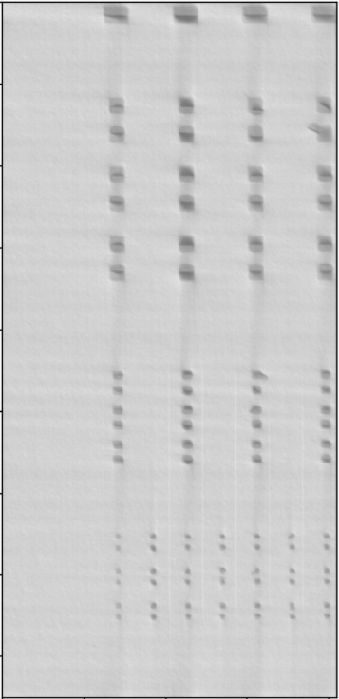

**Figure 19: Before and after image 2**

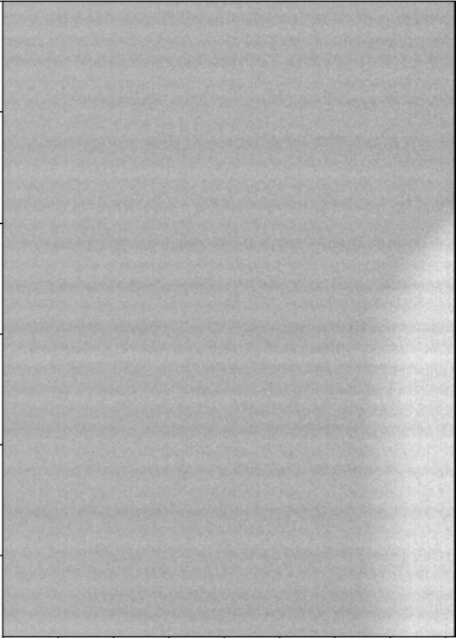

**Figure 20: Before and after image 3**

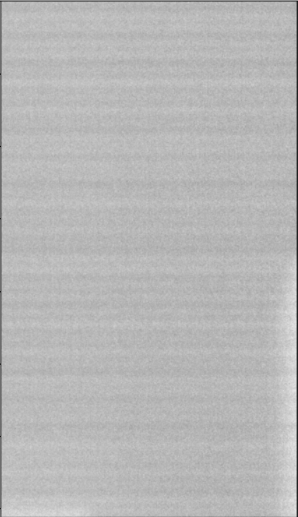

**Figure 20: Before and after image 4**

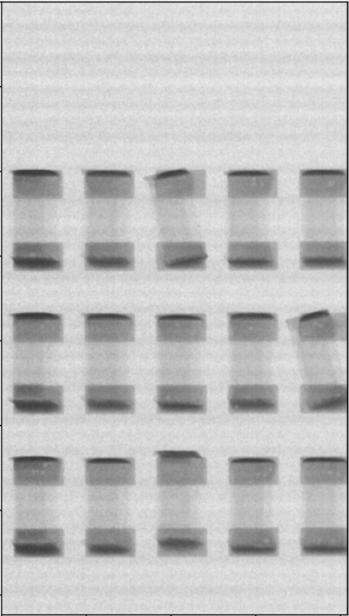

**Figure 20: Before and after image 5**

There are 10 or more other images but the results are the same. The banding effect is removed, while the black levels are decreased, but overall the objects are still distinguishable. However, image 5 shows vertical strips that are most obvious above and below which may interfere with the segmentation process. Thus, I tried to finetune and crop the right area of the magnitude spectrum to remove the banding lines while not showing these vertical strips.

After some trial and error I found that cropping the magnitude spectrum from (0, 1) to (10, 200) will remove most of the banding effect. I also found that removing frequency in x = 11 to x = 20 is the root cause of the vertical strips appearing. Thus, I removed (0, 1) to (10, 200) and (100, 1) to (700, 200) to achieve the best result in the output image.

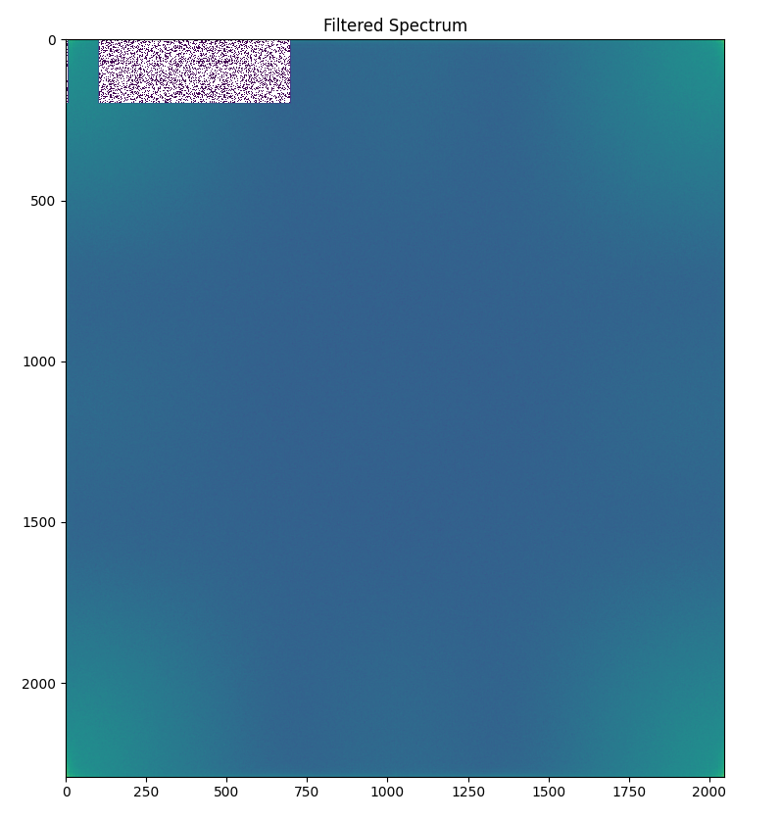

**Figure 21: 2nd try filtered magnitude spectrum**



**Figure 22: 2nd try closed up on cropped frequency**

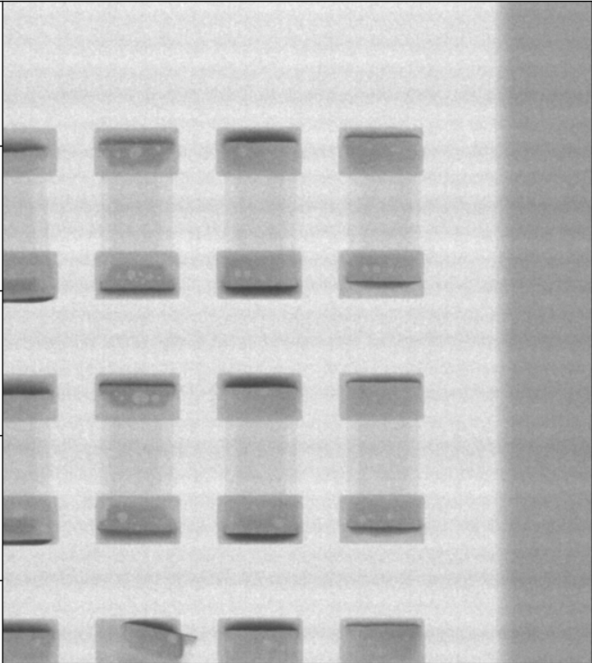 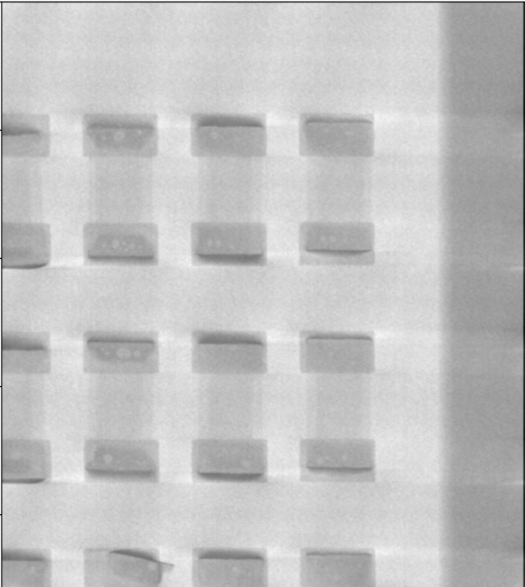

**Figure 23: 2nd try before and after image 1**

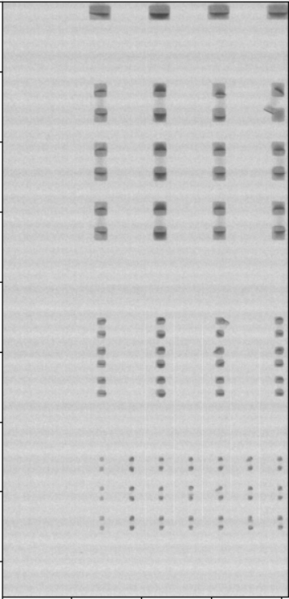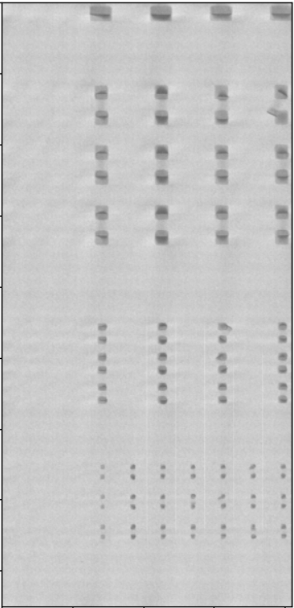

**Figure 24: 2nd try before and after image 2**

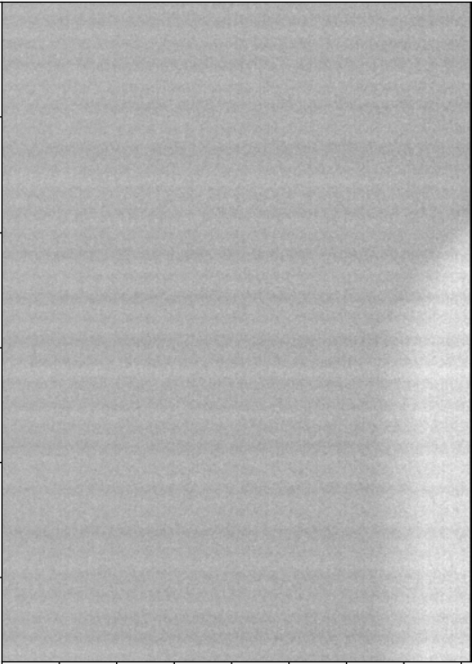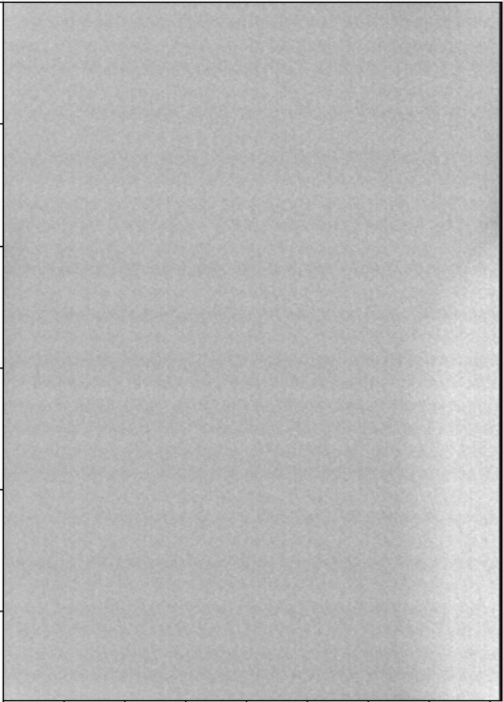

**Figure 25: 2nd try before and after image 3**

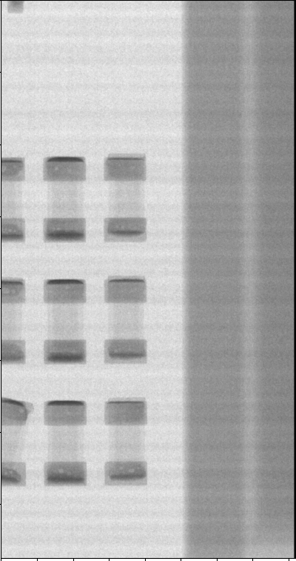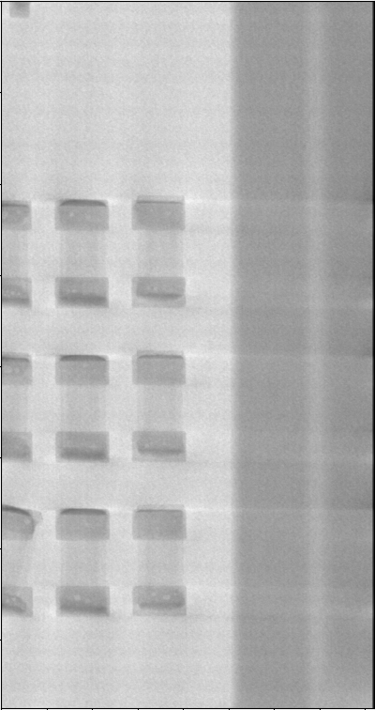

**Figure 23: 2nd try before and after image 4**

The results are overall improved after the second try. Most of the banding effects are removed and the horizontal strips that appear in Figure 20 are gone. The results are better than the first try but there are still some white horizontal lines in Figure 23 which will affect the image processing afterwards. Since the above two trials I have been cropping only the top left corner frequency, I decided to change my approach, which is to use fftpack.shift() to shift the low frequency contents into the centre of the magnitude spectrum. Since most of the details, banding effects are in the low frequency content, it is easier for me to crop the low frequency contents all together and see which area corresponds to which object or patterns (Figure 24). In the frequency that lies in the centre of the magnitude spectrum lies the information on the objects, thus I will keep the centre and crop only the frequency outside of the centre. I started by cropping a huge area above and below the centre to see which details are erased. If important details are not present I will decrease the area of cropping. If the important details reappear, this means that the important details lie in the difference between the initial cropped area and the 2nd cropped area. This is more clearly illustrated in Figure 25. To find unwanted frequencies this method is also used. After a few tries I found the area that produces results better than the 2nd try.

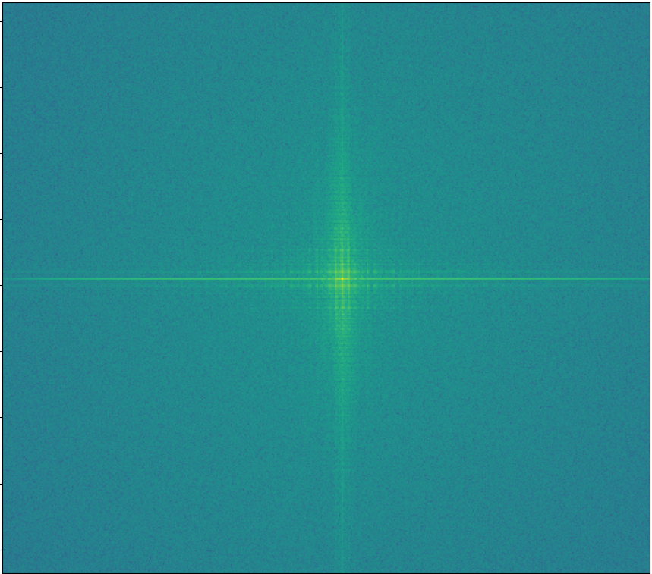

**Figure 24: Most important details are the low frequency**

**lie in the centre**



**Figure 25: Method of finding the unwanted frequencies**

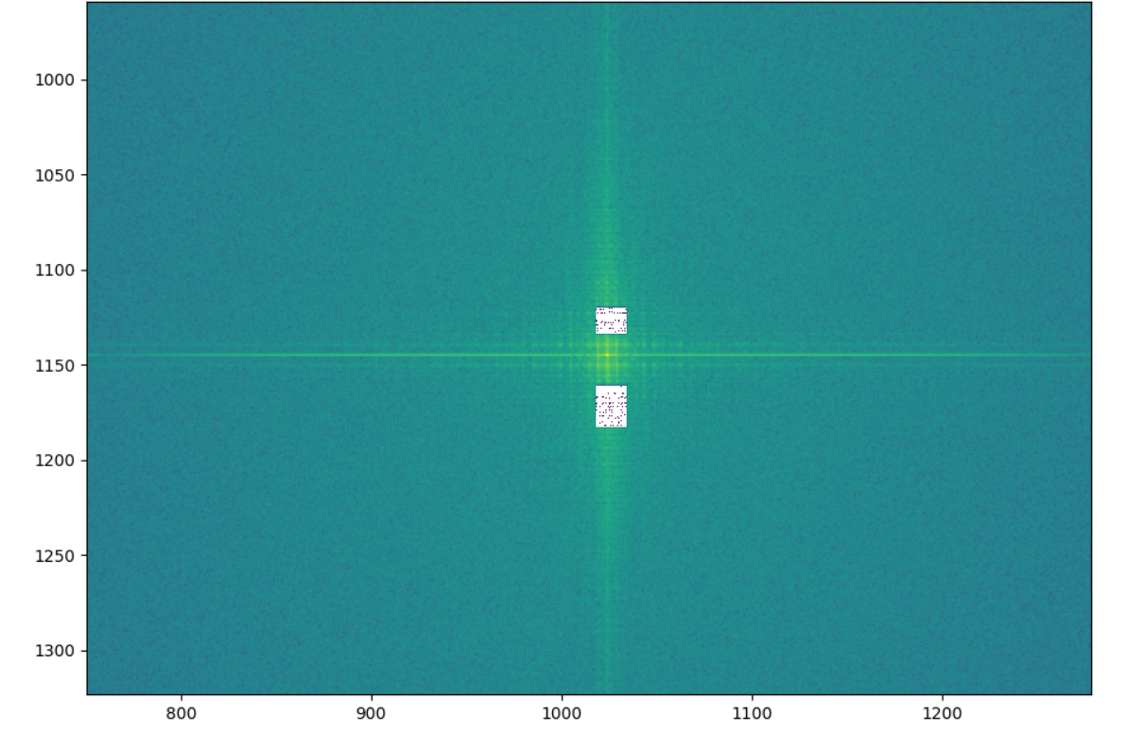

**Figure 26: 3rd try Filtered magnitude spectrum**

For the 3rd try, I found two areas of frequency that are responsible for unwanted artifacts in the image. One area of frequency which is responsible for the banding pattern, which is the smaller rectangle above. Another area of frequency is responsible for a thick white horizontal line in Figure 23. The equations to calculate the areas are shown below. Previously, The coordinates of the area I cropped were the same, but this is not ideal as the images have different dimensions. To adapt the cropped area to different dimensions these equations have to be used to remove the unwanted frequencies. It successfully removed the banding pattern because the frequencies of the banding pattern in each image is almost the same, thus it is located in the same position relative to the centre to the magnitude spectrum.

|  |
| --- |
| 1st cropped area = ( column * 0.4995 - 4 , row * 0.4889 ) to ( column * 0.4955 + 10 , row * 0.5171) |
| 2nd cropped area = ( column * 0.4995 - 4 , row * 0.5068 ) to ( column * 0.5005 + 10 , row * 0.5171) |

**Equation 3: 3rd try cropped areas**

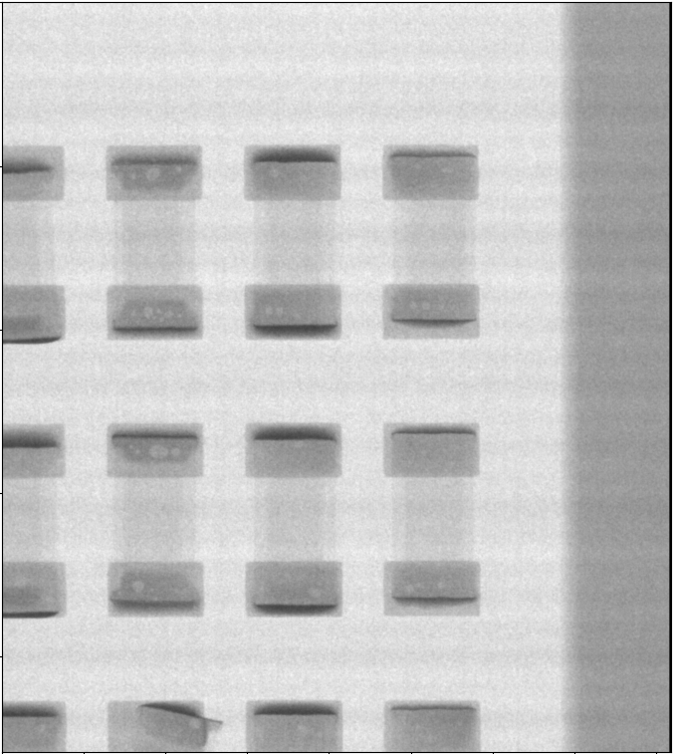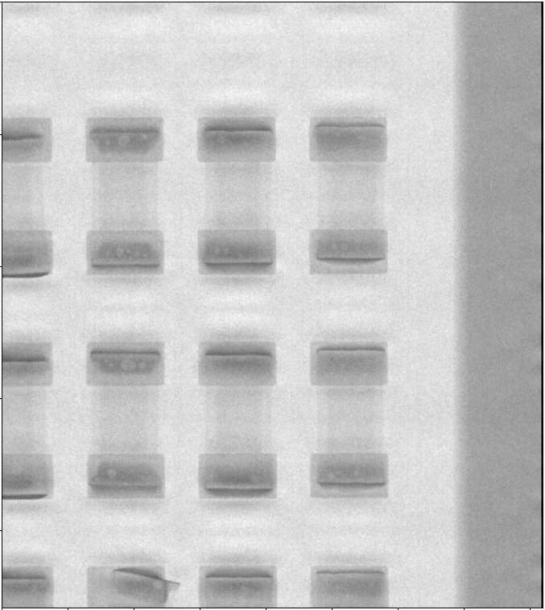

**Figure 27: 3rd try** **before and after image 1**

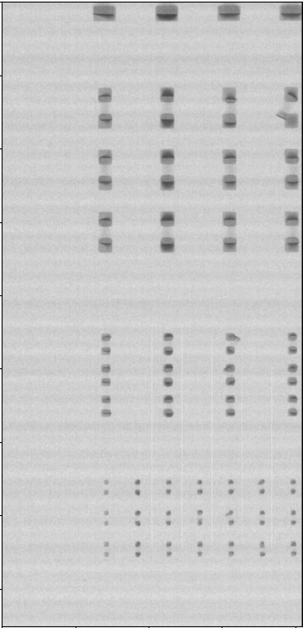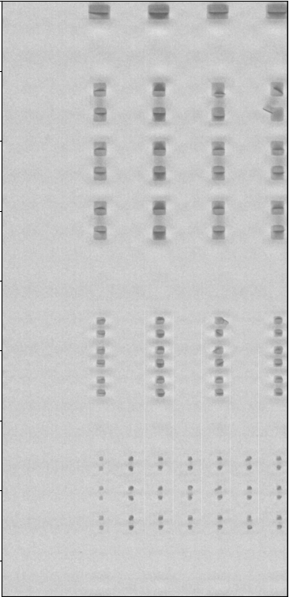

**Figure 27: 3rd try** **before and after image 2**

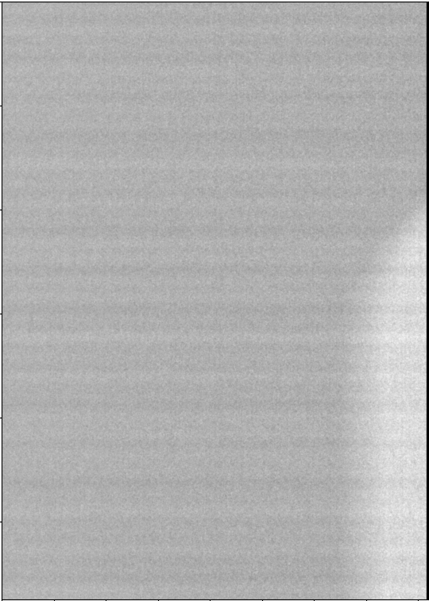

**Figure 27: 3rd try** **before and after image 3**

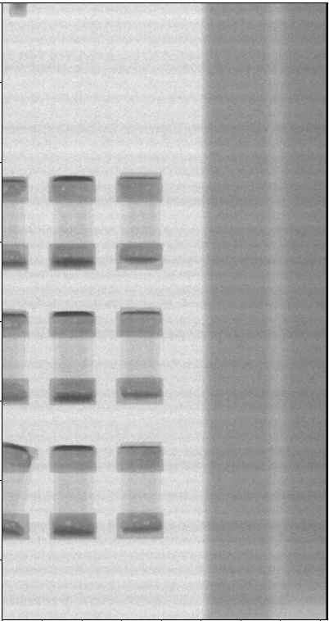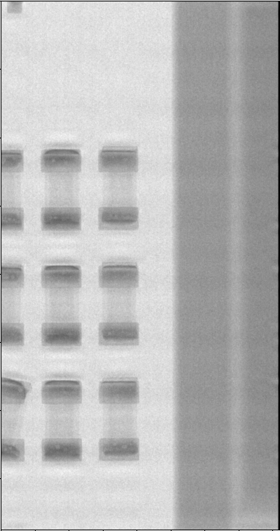

**Figure 27: 3rd try** **before and after image 3**

**Suggestions and Improvements**

First, the code takes about 1 to 2 seconds to display the resulting image which is quite slow and not very practical in real world applications of machine vision. This can be improved by optimizing the code. Second, the trial and error method used to find the unwanted frequency is very time consuming and the outcome is not certain as it is difficult to determine which frequency in the frequency domain corresponds to which pixels or blobs in the spatial domain. Ideally the algorithm is able to detect the unwanted frequency and is able to erase the frequency automatically without user input.

**Conclusion**

I have learned a lot about the frequency domain, fourier transform, and how it helps image processing to be done faster in comparison to spatial domain image processing. The aim to remove the banding effect off the images is also achieved. Future improvements can be made to make this algorithm more robust and viable for practical use.

**Reference**

1. Rafael C. Gonzalez, Richard E. Woods, *Digital Image Processing*, Third Edition, New Jersey, 2008.
2. Alrammah. O. (n.d.) *Image Enhancement -Spatial Filtering vs.Frequency Domain Filtering.* Retrieved from <https://www.academia.edu/35796053/Image_Enhancement_Spatial_Filtering_vs_Frequency_Domain_Filtering>
3. Dey S. (2018). *Hands-On Image Processing with Python*. Packt Publishing.
4. Smith S. W. (n.d.) *Fourier Image Analysis*. Retrieved from https://www.dspguide.com/ch24/5.htm